ISOM 3260

Database Design and Administration

Fall 2019

**Team Project Report**

TasteJAVA | (Group Number: 10)

|  |  |
| --- | --- |
| CHAN, Yik Fai | 2034 4799 |
| FONG, Kei Him | 2045 1437 |
| JIAN, Thomas | 2068 4319 |
| LI, Wai Yu | 2035 6510 |
| TSANG, Hin Huen | 2042 7113 |

1. **Introduction**

Our team is a group of IT consultants and developers who have developed a Point of Sales (POS) system for our company, TasteJAVA, which sells creative coffee drinks such as iced whiskey coffee and vanilla cold brew.

Using the SDLC methodology, on the stage of planning and analysis, we analyzed the general business functions required by the POS System and the overall data requirements. On the stage of design, we developed a conceptual data model using ER Diagram to understand various entities, attributes and their relat-ionships. We also transform the entity relationship diagram (ERD) into relations by developing a logical database model. In addition, a data dictionary is illustrated to design databases stored in Oracle SQL Server.

Our POS system include different functions for cashier, barista and managers. For cashier, they can place orders, update product information and insert new product information, to name but a few. For barista, they can update status for orders, view order list. For managers, the system enables managers to display the manager dashboard. Functions for customers and members are included.

Overall, the system aims to enhance the operation of our business, enabling the ordering process operate effectively and efficiently.

**2. Conceptual Data Model**

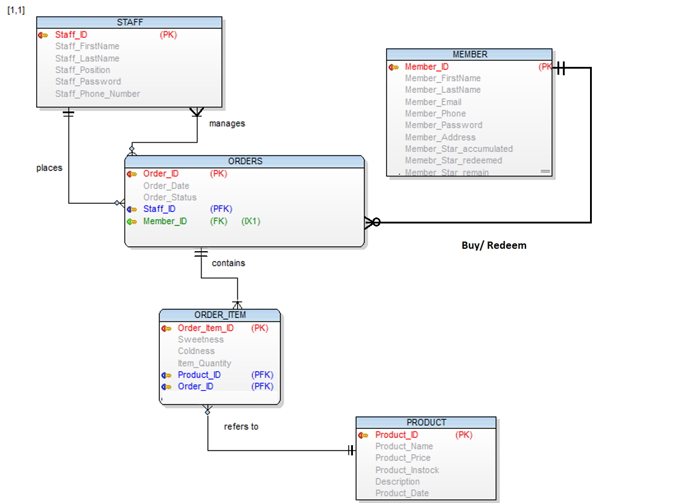

Entity of STAFF contains Staff_ID, Staff_FirstName, Staff_LastName, Staff_Position, Staff_Password, Staff_Phone_Number. Staff_ID is the primary key.

Entity of ORDERS contains Order_ID, Order_Date, Order_Status, Staff_ID and Memer_ID and Redeem. Order_ID is the primary key while Staff_ID and Memer_ID are the foreign keys.

Entity of ORDER_ITEM contains Order_Item_ID, Sweetness, Coldness, Item_Quanity, Product_ID and Order_ID. Order_Item_ID is the primary key while Staff_ID, Order_ID and Product_ID are the foreign keys.

Entity of PRODUCT contains Product_ID, Product_Name, Product_Price, Product_instock, Description and Product_Date. Product_ID is the primary key.

Finally, entity of MEMBERS contains Member_ID, Member_FirstName, Member_LastName, Member_Email, Member_Phone, Member_Password, Member_Address, Member_Star_accumulated, Member_Star_redeemed, Member_Star_remain. Member_ID is the primary key.

**3. Logical Data Model**

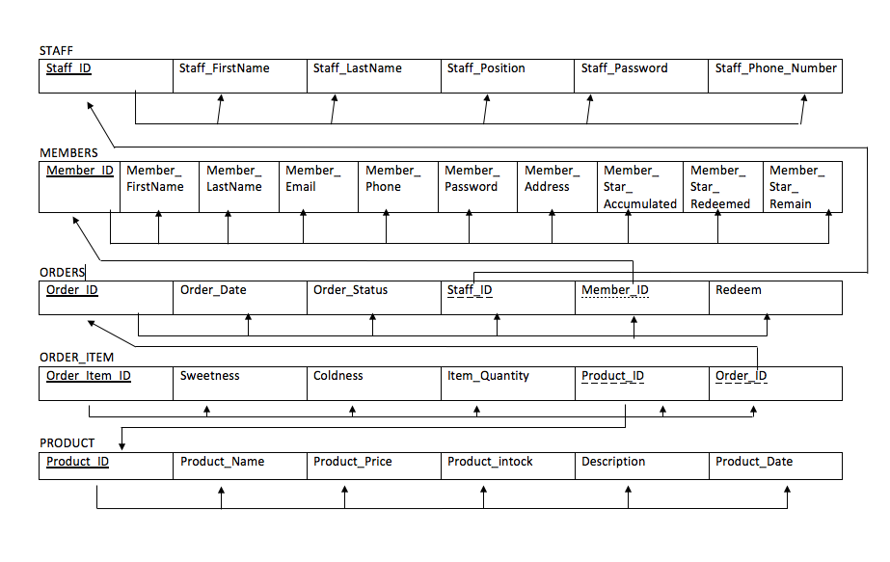

**4. Data Dictionary**

|  |  |  |  |  |  |  |
| --- | --- | --- | --- | --- | --- | --- |
| **Entity: ORDER_ITEM** | | | | | | |
| **Attributes** | **Datatype** | **PK** | **FK** | **Length** | **NULL** | **Description** |
| Order_Item_ID | NUMBER | ✓ |  | 10,0 | FALSE | Uniquely identifies of the entity of ORDER_ITEM |
| Order_ID | NUMBER |  | ✓ | 10,0 | FALSE | Uniquely identifies for entity of ORDERS |
| Product_ID | NUMBER |  | ✓ | 10,0 | FALSE | Uniquely identifies of the entity of PRODUCT |
| Sweetness | VARCHAR2 |  |  | 30 | TRUE | Sweetness of a drink |
| Coldness | VARCHAR2 |  |  | 30 | TRUE | Coldness of a drink |
| Item_Quantity | Number |  |  | 10,0 | FALSE | Quantity of drinks ordered by customers |

|  |  |  |  |  |  |  |
| --- | --- | --- | --- | --- | --- | --- |
| **Entity: MEMBER** | | | | | | |
| **Attributes** | **Datatype** | **PK** | **FK** | **Length** | **NULL** | **Description** |
| Member_ID | NUMBER | ✓ |  | 10 | FALSE | Uniquely identifies for the entity of MEMBER |
| Member_FirstName | VARCHAR2 |  |  | 30 | TRUE | First Name of a member |
| Member_LastName | VARCHAR2 |  |  | 30 | TRUE | Last Name of a member |
| Member_Email | VARCHAR2 |  |  | 30 | TRUE | Email address of a member |
| Member_Phone | Number |  |  | 20 | TRUE | Phone number of a member |
| Member_  Password | VARCHAR2 |  |  | 30 | TRUE | Password of a member |
| Member_  Address | VARCHAR2 |  |  | 30 | TRUE | Address of a member |
| Member_Star_  accumulated | Number |  |  | 10,0 | FALSE | The redemption point available for a member |
| Member_Star_  redeemed | Number |  |  | 10,0 | FALSE | No. of points redeemed by a member |
| Member_Star_  remain | NUMBER |  |  | 10,0 | FALSE | The remaining accumulation points left after redeem |

|  |  |  |  |  |  |  |
| --- | --- | --- | --- | --- | --- | --- |
| **Entity: ORDERS** | | | | | | |
| **Attributes** | **Datatype** | **PK** | **FK** | **Length** | **NULL** | **Description** |
| Order_ID | Number | ✓ |  | 10,0 | FALSE | Uniquely identifies for entity of ORDERS |
| Order_DATE | Date |  |  | Sys  default | FALSE | Date when the order is placed |
| Order_STATUS | Varchar2 |  |  | 30 | FALSE | Show whether the order is “In Progress”/  ”Completed”/  “Cancelled” |
| Staff_ID | Number |  | ✓ | 10,0 | FALSE | Uniquely identifies for the entity of STAFF |
| Member_ID | Number |  | ✓ | 10,0 | FALSE | Uniquely identifies for the entity of MEMBER |
| Redeem | VARCHAR2 |  |  | 30 | TRUE | To display whether customers purchase a drink through redeeming points or not |

|  |  |  |  |  |  |  |
| --- | --- | --- | --- | --- | --- | --- |
| **Entity: PRODUCT** | | | | | | |
| **Attributes** | **Datatype** | **PK** | **FK** | **Length** | **NULL** | **Description** |
| Product_ID | Number | ✓ |  | 20,0 | FALSE | Uniquely identifies of the entity of PRODUCT |
| Product_Name | Varchar2 |  |  | 30 | TRUE | Name of each product |
| Product_Price | Number |  |  | 20 | TRUE | Price of each product |
| Product_InStock | Number |  |  | 5,2 | TRUE | Show the remaining stock of each product |
| Description | Varchar2 |  |  | 30 | TRUE | Brief description of each product |
| Product_Date | Date |  |  | Sys  date | FALSE | Record the time at which a new product enter the database  For promotion purpose |

|  |  |  |  |  |  |  |
| --- | --- | --- | --- | --- | --- | --- |
| **Entity: STAFF** | | | | | | |
| **Attributes** | **Datatype** | **PK** | **FK** | **Length** | **NULL** | **Description** |
| Staff_ID | Number | ✓ |  | 10 | FALSE | Uniquely identifies of the entity of STAFF |
| Staff_FirstName | VARCHAR2 |  |  | 30 | FALSE | First name of staff |
| Staff_LastName | VARCHAR2 |  |  | 30 | FALSE | Last Name of staff |
| Staff_Position | VARCHAR2 |  |  | 30 | FALSE | The job position of staff |
| Staff_Password | VARCHAR2 |  |  | 30 | FALSE | Pasword of staff |
| Staff_Phone_  Number | Number |  |  | 20,0 | FALSE | Phone number of staff |

**5. Functional Requirements**

**Staff**

1. Cashier

1.1. Allow staff to insert new product information

1.2. Allow staff to update product information

1.3. Allow staff to update order status for orders

1.4. Allow staff to place an order for customer

1.5. Allow staff to conduct registration for members

1.6. Allow staff to retrieve the login password/reset the login password in case they have forgotten

1. Barista

2.1. Allow staff to update order status for order

2.2. Allow staff to view order list

2.3. Allow staff to retrieve the login password/reset the login password in case they have forgotten.

1. Manager

3.1. Allow manager to display “Manager Dashboard” (refer below for the manager dashboard requirement)

* Show total amount of daily and monthly sales
* Show all sales order of today (And be able to view detail of each sales order)
* Show the 5 most popular products and each of the product sales (in terms of quantity)
* Show the top 5 members and their individual sales amounts
* Show sales of a particular product, in terms of quantity sold
* Show the number of orders of different statuses

3. 2. Allow manager to retrieve the login password/reset the login password in case they have forgotten.

**Customers**

* Allow members to earn stars at purchase time
* Allow members to redeem rewards

**6. Conclusion**

Currently, our system is a newly-launched platform, which provides the basic functions for different stakeholders. For customers, they can earn stars at purchase time and redeem rewards. Customers will also know the points remained after redeeming the rewards. For Managers, they can use the manager dashboard to obtain information related to sales.For example, managers can view manager dashboard for a summary of total daily and monthly sales, sales order of the day, the five most popular products, five members with highest spending, sales of a particular product, number of orders of different statues. For Barista, they can update the status of order and view the order list. For Cashier, they can insert new product information. For instance, new promotional item will be displayed in the system. In addition, cashier can conduct registration for members and place an order for them.

This system, in the short run, enhances the operation of TasteJAVA smoothly.

In the long run, our team wishes to implement more features, such as building a business Intelligence by “Purchase History” and relevant availability which indicates the ingredients of the products, stock and availability of each ingredient.

Further development of the system is subject to the company's budget on the system, user feedback and the demand of drinks. Overall, we hope that our system can provide a holistic experience to our users.

**7.Assumptions (0.5 -1 pages)**

MEMBERS

1. Members will always remember their email and password for login
2. Members’ name can also contain numbers.
3. Members’ phone no can include less/more than 8 digits

STAFF

1. Staff could remember their staff ID for login.

2. Staff could remember their phone number for reset password.

3. Staff members have their accounts directly created in database and do not need an additional interface for registration.

1. Staff members understand what this website is about and for before administration.
2. The phone number of each staff is unique.

ORDER

1. Each person will only order 10 different items for one purchase in one shopping cart.
2. Inventory will only will reduced when the status is changed to ‘Completed’
3. Staff will not change the order status anymore if the order are already ‘Completed’.
4. The maximum number of “In - progress” order is 20

PRODUCT

1. Can have more than one product with the same name

REDEEM

1. Member will only redeem one product for one time.